# **1. Creating and Renaming Files/Directories**

* Create a directory named test_dir using mkdir.

For creating a directory we can use the mkdir command like this

**mkdir test_dir**



* Inside test_dir, create an empty file called example.txt.

To create a file inside the directory first we need to use the CD command to go into the directory and then use the touch command to creat a file. The usage of the commands are shown below

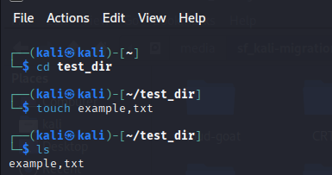

* Rename example.txt to renamed_example.txt using mv

mv command can be used as shown below to rename the file

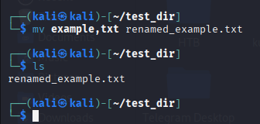

# 2. Viewing File Contents

Use cat to display the contents of /etc/passwd.

As /etc/passwd contains sensitive info pertaining to user information i’m masking the contents of the file for security and privacy reasons.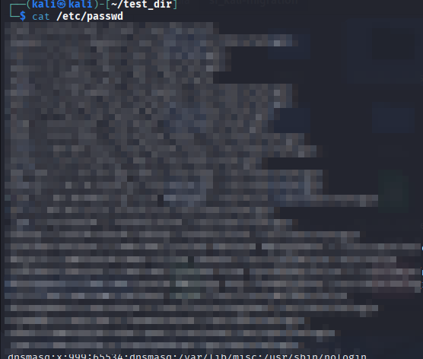.

Display only the first 5 lines of /etc/passwd using head.

To display the first five lines of the files we can use the head command with a -n flag to specify the number of lines to be displayed.

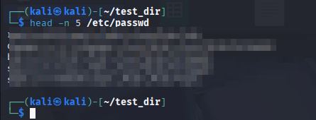

Display only the last 5 lines of /etc/passwd using tail.

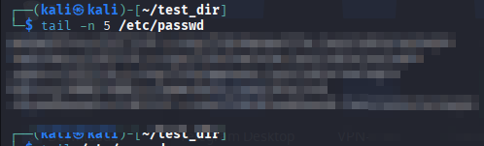

# 3.Searching for Patterns

Use grep to find all lines containing the word "root" in /etc/passwd.

To find all the lines containing the word root we could use grep command with -F flag. I’m using the -F flag to ***treat the word root as a fixed string rather than a regular expression***. I’m masking the contents of ./etc/passwd file for security reasons..



# 4. Zipping and Unzipping

Compress the test_dir directory into a file named test_dir.zip using zip.

To compress the directory test_dir to a zip file name test_dir.zip we can use the zip command

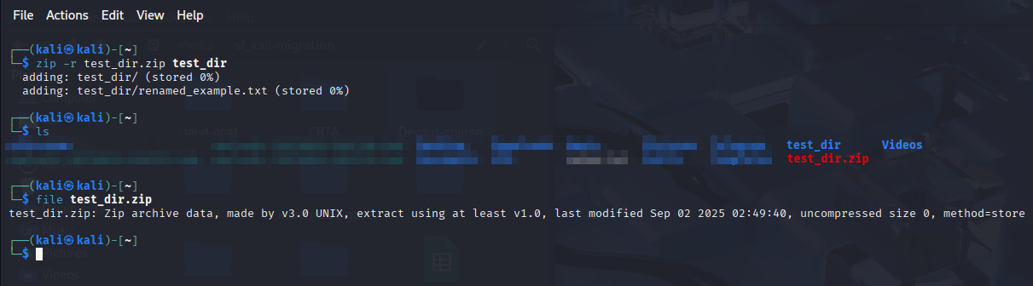

Unzip test_dir.zip into a new directory named unzipped_dir.

To do this task we can use unzip command with the -d flag to specify the unzipped dir name if the directory doesn't exist it will be created and then the zip files contents are unzipped in to that directory

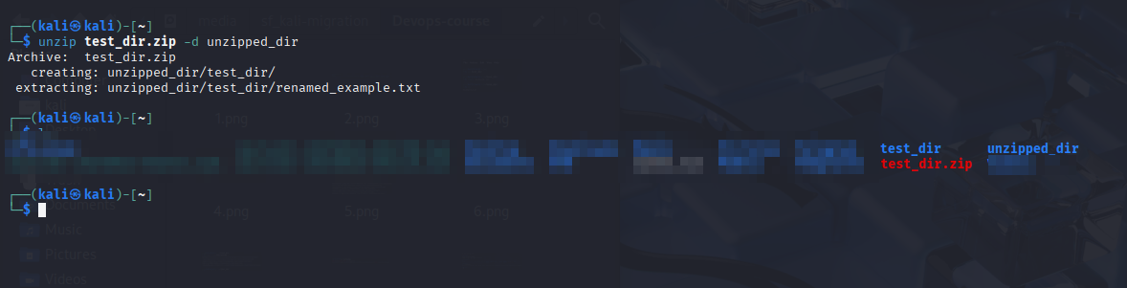

# 5. Downloading Files

Use wget to download a file from a URL (e.g., <https://example.com/sample.txt>).

Instead of downloading file from a public website I have hosted a simple web server in my local machine and downloaded a file hosted on it using wget. I did it this way because i felt that the idea here is to demonstrate the use of wget rather than visiting the public website. The only difference in the usage of wget command will be is in locally hosted sites is that there will be an ip address in place domain name thats it. The usage of wget is depicted in the below screenshot.

# 

# 6. Changing Permissions

Create a file named secure.txt and change its permissions to read-only for everyone

using chmod.command we can specify the permissions of file as we only require read-only permissions for users, groups and others we can use 444 as our permissions

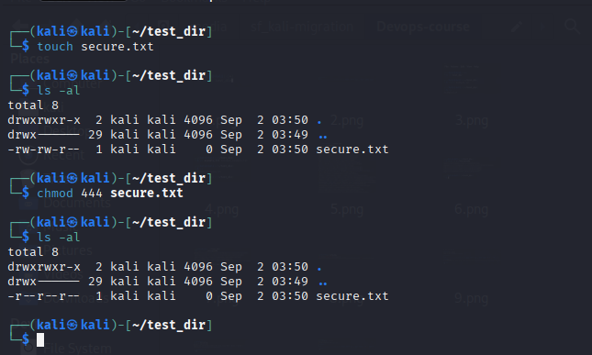

# 7. Working with Environment Variables

Use export to set a new environment variable called MY_VAR with the value "Hello, Linux!".

As exclamation is a special character and in order to print it i had to escape it

